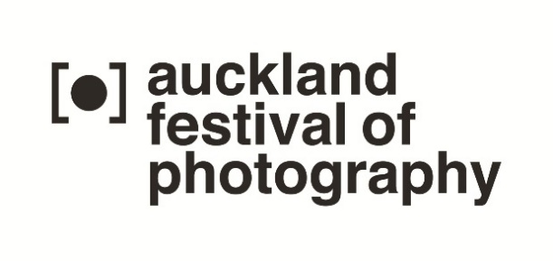
Media Release May 2016

2016 AUCKLAND FESTIVAL OF PHOTOGRAPHY 2-24 jUNE notes for editors 1/2
HOME exhibition exposes Aucklanders to complex reflection
More than 100 exhibitions and events make up 2016’s Auckland Festival of Photography (AFP), including:
- Nikon Auckland Photo Day on 11 June
- an exhibition of winning images from 11 years of the competitions in The Cloud on the waterfront (18-24 June), and
- New work by Russ Flatt – the 2016 recipient of the AFP’s Annual Commission by Sacred Hill - one of fifteen HOME themed exhibitions in June’s festival
Flatt’s new work in the Silo 6 exhibition space in Wynyard Quarter will be on show alongside an international line up, selected by New York-based curator Simone Douglas, of photo artists - including four in attendance during AFP’s first week: USA-based artist collaborative, Lin +Lam, and Australia-based Shan Turner-Carrol, Shoufay Derz and Eva Marosy-Weide. Other artists whose work is featured include Anna Carey, Ian Strange and Sean Lowry.
“The HOME theme is a rich and complex one to explore,” says AFP public participation director Julia Durkin. ”In Auckland we are having to grapple with regional growth, fading dreams of home ownership, migrant hopes and expectations, and refugees searching for new identity. These elements all feed into the ‘conversation’ that this year’s HOME content provides audiences.”
2016’s programme illustrates AFP’s role in bringing significant work by overseas-based photographers to New Zealand. “The connections built up over time mean we can provide Auckland audiences with a high calibre international programme,” Julia Durkin says.
The festival is also a platform for the best work produced by New Zealand-based photographers, celebrated in 25 ‘signature’ exhibitions within the festival’s compact 2-24 June timeframe – and 18 ‘talking culture’ events featuring contributions from leading experts from India, China, New Zealand, Singapore, USA and Australia [see next page].
"AFP has become the most significant visual arts event in the New Zealand winter calendar," Julia Durkin says. "AFP includes but goes beyond the major galleries, involving Auckland-based photographers in its extensive fringe programme of 44 exhibitions. AFP is also building a unique archive of the region thanks to the popular appeal of AFP’s annual Nikon Auckland Photo Day competition."

For more information and interview opportunities, please contact:
Victor van Wetering, media manager, Auckland Festival of Photography, (09) 849 6565.

Details available at http://www.photographyfestival.org.nz/programme/index.cfm

2016 AUCKLAND FESTIVAL OF PHOTOGRAPHY 2-24 jUNE notes for editors 2/2
A sampling of what’s on offer:
- Nando Azevedo’s New Zealanders Now: From Refugees to Kiwis (Ponsonby Central, 31/5-12/6) – supported by Auckland Refugee Community Coalition and Amnesty International.
- 2016 Annual Commission recipient Russ Flatt presents new work (Silo 6, 2-20 June).
- Sim Chi Yin’s The Rat Tribe features images of low wage migrant workers living in Beijing’s basements and air raid shelters (Silo 6, 2-20 June).
- Raymond Sagapolutele portrait series, Out of Context, about his generation born in Aotearoa New Zealand to Pacific Island parents. (Auckland Art Gallery, 12 June, 3pm)
- Simone Douglas, Associate Professor at Parsons, The New School in New York, talks (2pm, 4 June, Auckland Art Gallery) about the Home exhibitions (Silo 6, 2-20 June) she curated.
- Oh Soon-Hwa’s My Quiet Dream features portraits of young women who have married foreigners to provide financial support to their families (Auckland Art Gallery, 4 June, 3pm)
- Wen Huang introduces images from China’s International Press Photo contest (Auckland Art Gallery, 3pm, 6 June).
- Australian Alasdair Foster is interested in the ‘democratisation of the arts and the failure of arts education’. Alasdair chairs Photography + Education (3 June, 12pm), and presents Disquietude: Landscape and the Australian imagination (Auckland Art Gallery, 5 June, 1pm).
- Future Projections – images created by photography students in Australia, Singapore, the USA and Auckland’s AUT, MIT, UCOL, Unitec and Whitecliffe in Auckland.
- James Dooley on the Alexia Foundation’s support of photojournalism (Auckland Art Gallery, 1pm, 2 June) including The Long Night (Auckland Art Gallery, 6.30pm, 1 June) documentary on the US sex industry.
- International artists, curators and photojournalists attending AFP 2016 include: Simone Douglas, Jim Rainer and James Dooley (USA), Aquin Mathews and Nikita Upreti (India), Sam Harris, Alasdair Foster, Shan Turner-Carrol, Gael Newton and Shoufay Derz (Australia),
Oh Soonhwa (Singapore), Johnny McCormack (England) and Wen Huang (China).

For more information and interview opportunities, please contact:
Victor van Wetering, media manager, Auckland Festival of Photography, (09) 849 6565.

