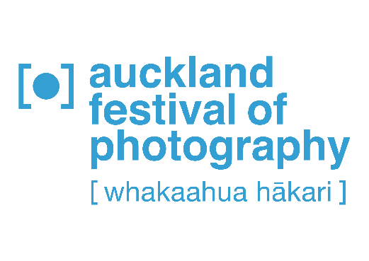
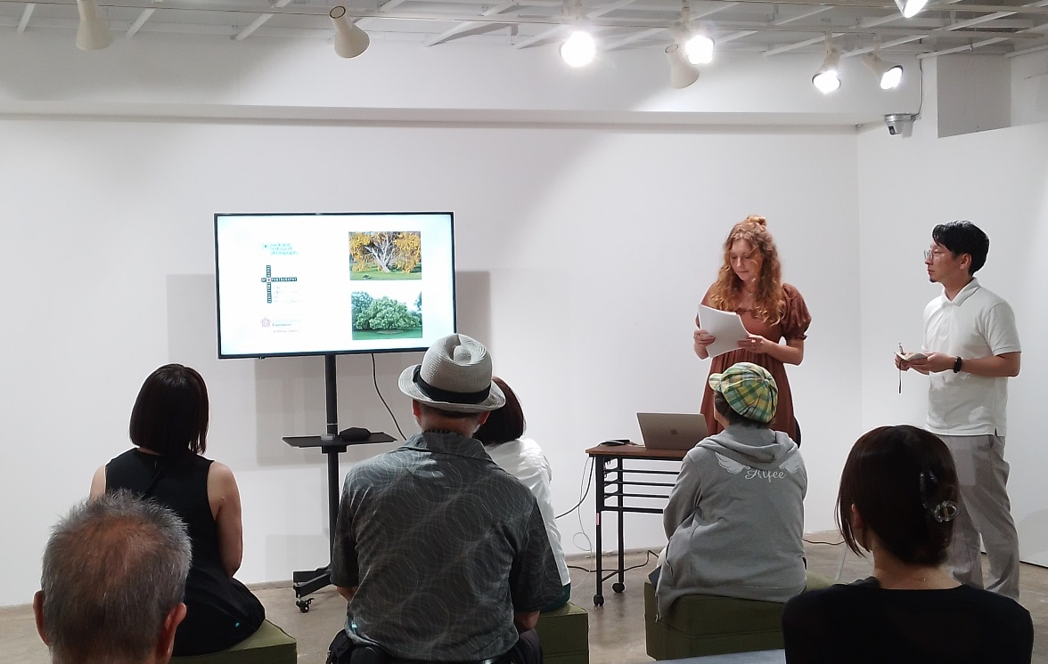

Hannah Rose Arnold presents her end of Kōwhai research residency talk, Sept 2023.

Kōwhai Residency opportunities 2024

An award for contemporary photographic art residency jointly founded by New Zealand's Auckland Festival of Photography founder/CEO, Julia Durkin, sponsored by The Bass Player Ltd, and Japan project partner, Ihiro Hayami, Founder, Director T3 Photo Festival, Tokyo for photographic/visual imaging New Zealand artists/photography practitioners, curators who are keen to develop their photography internationally in Japan.

We are opening applications for a call for the next exciting residency Awards. The inaugural residency was research based and was taken by Hannah Rose Arnold, an artist/photographer with a proven track record of a work/works. Our successful 2023 creator residency applicant was Jenna Eriksen, a multi-disciplinary film maker and the new residency artists who apply must be similarly able to demonstrate how they will benefit from building on their practice to date and are willing to take a step forwards, through the time in Tokyo to further their knowledge and practice and work.

Two residencies are available in 2024 –

NZ artist Research residency - to conduct research in the arts and culture or research for their own new creative activities. Photography and moving image/video. 5 weeks research residency – August/Sept (tentative 6 August to 9 Sept). Now open for applications until 11 May 2024.

NZ artist Creator residency – Photographic, moving image works created and research conducted in residence and for the artists photography practitioners, curators themselves to give presentations on their activities and works at other opportunities. 8 weeks creator residency – End Oct to mid Dec (tentative 27 Oct to 15 Dec). Closed until June 2024.

The New Zealand artists/ photographic professionals are to be selected by recommendation from a peer assessment, based on an advance invitation to apply.

During their residency, the selected x 1 artists/photography practitioners, curator have the use of single studio accommodation, receive administrative support from the Trust and our partners in Tokyo. The artist will be paid a weekly stipend.
The Kōwhai Residency provides an opportunity to support and promote a New Zealand photographer, practitioners, curators as well as create a cultural and artistic infrastructure between NZ & Japan.
The Kōwhai Residency comprises one talented artist, photography practitioners, curators to support emerging to mid-career photographic professionals. The research and creator residency for exhibition of work that results, are a combination of the photographic professional’s vision and the Tokyo team expertise to the development of the photographic arts. The Kōwhai Residency allows the artists/ photographic professionals to freely research in a self-guided way and to inform current or new photographic works, the Festival provides travel, single room accommodation, professional support & weekly consulting by an experienced director, curator.
– NZ artist Research residency - to conduct research in the Japanese arts and culture or research for their
own new creative activities. Only photography and moving image/video related.
5 weeks research residency – August/Sept (tentative 6 August to 9 Sept)

Criteria you must meet are:
1) Must be NZ based and resident or citizen of New Zealand
2) Must be able to travel and be in residence from New Zealand in early August, departing the 6th of
August and to return to New Zealand to mid-September, approx. 9th Sept, for a 5 week residency.
3) Must hold all relevant travel documents for entry to Japan – passport valid for at least 6 months from August 2024 – please check this before applying.
4) Must be over 23 years old, having graduated from educational studies, have at least one body of
work which shows talent and promise.
5) Airfares will be economy return from and returning to New Zealand direct to/from Japan, paid for
by the Kowhai Residency project and no cash alternative will be paid in exchange for the airfare.
6) Weekly stipend will be paid into the NZ bank account of the resident artist in NZ$ starting on day 1
of arrival in Japan and 7 days thereafter until conclusion of the residency. (NZ$600 per week).
7) Transfers to and from Auckland airport are not included in the airfare which is ex Auckland.
8) Transfers to and from Narita Airport in Tokyo will be advised but not booked these are to be paid
by the artist/photographer on arrival.
9) All details for how to get into the city and to the residency programme supporter at TIP in Kyobashi
will be provided.
10) Agreement of the terms and conditions must be signed and submitted with the applications.
11) For the successful applicant of the offer, a contract and care of the accommodation facility
agreement must be signed by the resident artist prior to travel bookings being made.
12) The selection panel decision is final and no correspondence will be possible.
-------------------------------------------

What to send in your application:
1) Bio/CV of your proven track record to date
2) Examples of the previous or current research project include images and references, weblinks in a
PDF. Maximum 4 pages.
3) Cover email/letter to explain why this project and your work should be the one selected, articulate
the outcomes you feel will be achieved.
4) Attach a copy of these terms and conditions signed by the applicant

